[State Abbreviation] After-Action Report
[Program Office/Sub-Topic]
[Month Year] DRAFT [Draft #.#]

July 28, 2021 (Draft #)

Administrative Handling Instructions
The title of this document is: [State Abbreviation] After-Action Report.
The information gathered in this After-Action Report (AAR) is classified For Internal Use Only. This draft AAR contains observations that have yet to be validated and will not be final until reviewed by relevant incident subject matter experts for accuracy. This document should be safeguarded, handled, transmitted, and stored in accordance with appropriate security directives.
Points of Contact:
[Name]
[Division]
[Office address]
[Email address]

[Name]
[Division]
[Office address]
[Email address]

Contents
Administrative Handling Instructions i
Contents ii
Executive Summary 1
Key Findings 1
Next Steps 1
Analysis of Core Capabilities 2
Scope and Methodology 3
Data Collection 3
Observations 4
[State Abbreviation]-### (Drop Down): [Program Area] 4
Conclusion 6
Appendix A: Improvement Plan A-1
Appendix B: Observation Components B-1
Appendix C: Acronym List C-1
Appendix D: Participating Organizations D-1

Executive Summary
[Introduce the topic of the AAR, including high level details and relevant dates. Relevant details may include a brief description of the topic, its effects on surrounding areas/communities, and actions taken in response to the topic. Depending on the broadness of the topic, the AAR can focus on specific examples. For instance, a 2017 Hurricane Season AAR identified the total number of hurricanes that occurred during the season, but focused on Hurricanes Harvey, Irma, and Maria. The Executive Summary described when the hurricanes formed or made landfall and how they affected the areas they passed through. The overall section should be about one and a half pages in length. This section is not meant to be comprehensive. Focus on key information that summarizes the topic, key dates, impacts, and your response.]

Key Findings
[In a few sentences, briefly describe how your office conducted an AAR in response to the topic above. What was the AAR’s focus? How is your agency using lessons learned from the AAR? Using the example above, XXX conducted an AAR of its preparation, response, and recovery operations to Hurricanes Harvey, Irma, and Maria. XXX used the findings to improve its response and recovery efforts]
[State the number of findings and focus areas that you identified (e.g., “XXX identified XX findings across XX focus areas”). XXX often identifies key findings that focus on a similar topic issue/area. In Table 1, identify these focus areas and group relevant findings.]
Table 1: Summary of Key Findings
Key Findings
[Key Finding 1] [Use left numbering format with Arabic numerals.]
[Key Finding 2]
[Key Finding 3]
[Key Finding 4]

Next Steps

[In a few sentences, briefly summarize how XXX may plan to respond to lasting effects of the incident topic. For example, XXX will use the identified findings to improve future disaster operations and support the long-term recovery of communities affected by the hurricanes.]

Analysis of Core Capabilities
Aligning observations and core capabilities provides a consistent taxonomy for evaluation that transcends individual incidents to support preparedness reporting and trend analysis. Table 2 includes the observations, aligned core capabilities, and performance ratings for each core capability as observed during the incident and determined by the evaluation team.
Table 2: Summary of Core Capability Performance
Observations | Primary Core Capability | Primary Lifeline | Performed without Challenges (P) | Performed with Some Challenges (S) | Performed with Major Challenges (M) | Unable to be Performed (U)
[Observation 1] | [Core capability] | [Lifeline]
[Observation 2] | [Core capability] | [Lifeline]
[Observation 3] | [Core capability] | [Lifeline]
[Observation 4] | [Core capability] | [Lifeline]

Performed without Challenges (P): The targets and critical tasks associated with the core capability were completed and did not negatively impact the performance of other activities. Performance of this activity did not contribute to additional health and/or safety risks for the public or for emergency workers, and it was conducted in accordance with applicable plans, policies, procedures, regulations, and laws.
Performed with Some Challenges (S): The targets and critical tasks associated with the core capability were completed and did not negatively impact the performance of other activities. Performance of this activity did not contribute to additional health and/or safety risks for the public or for emergency workers, and it was conducted in accordance with applicable plans, policies, procedures, regulations, and laws. However, opportunities to enhance effectiveness and/or efficiency were identified.
Performed with Major Challenges (M): The targets and critical tasks associated with the core capability were completed but some or all of the following were observed: demonstrated performance had a negative impact on the performance of other activities; contributed to additional health and/or safety risks for the public or for emergency workers; and/or was not conducted in accordance with applicable plans, policies, procedures, regulations, and laws.
Unable to be Performed (U): The targets and critical tasks associated with the core capability were not performed.

Scope and Methodology
This AAR includes information collected primarily from/by [describe number of deployments, interviews, etc.]. Observations were developed based on data collected from [briefly describe the types of data collection method(s) used here].

Data Collection
[Describe collection methodology below. List Data Collection Metrics in Table 3. List collection objectives in Table 4.]
[Describe in greater detail how data was collected for this particular AAR. This can include the types of methods used (e.g., interviews, hot washes, focus groups, surveys, etc.), when data collection took place (e.g., “Interviews occurred for two weeks from MM/DD/YYYY to MM/DD/YYY”), individuals involved in the data collection process (both data collectors and the targets of data collection), the scale of data collection (from how many people were data collected from?). Include one sentence that introduces Table 3 as a summary of data collection metrics. Similarly, summarize the purpose for data collection in one sentence that introduces Table 4.]
Table 3: Data Collection Metrics
Interview Participants | Hot Washes | Field Site  Visits | Survey Responses | Focus Groups | Feedback  Forms
[Number of participants] | [Number of hot washes] | [Number of field site visits] | [Number of survey responses] | [Number of focus groups] | [Number of feedback form responses]

Table 4: Collection Objectives
Incident Collection Objectives | Other Objectives
- [List major collection objective from the Disaster Collection Analysis Plan (CAP)] | - [List other incident collection objectives such as program-specific objectives]

Observations
[Replace “Observations” above with the type of observation you are documenting: “Strength”, “Potential Best Practice”, “Area for Improvement”, or “Innovation”.]

[State Abbreviation]-### (Drop Down): [Program Area]
[The number above is unique to each observation. Place a topic sentence summarizing the observation here. This section (observation number through Additional Validation Requirements) should be repeated for each Observation.]

Strategic Goal
[Consider which goal the Observation supports. You may select more than one. An ‘X’ in the checkbox will indicate that the Strategic Goal was selected.]
☐ 1. Insert your agency goals (Example: Build a Culture of Preparedness)
☐ 2. Ready the Jurisdiction for Catastrophic Disasters
☐ 3. Insert your goals

Discussion
[The text in this section should provide supporting evidence for the topic sentences above. For example, if the topic sentences focused on inadequate staffing and insufficient private areas to conduct interviews, this section might have two paragraphs: one concerning staffing levels and another on confidential work areas. The supporting evidence can include timing, location, scope, and consequences. Which office/program was understaffed? How understaffed was this office or program? Did the understaffing lead to any adverse consequences, such as a backlog? When and how was the understaffing resolved (e.g., a request was made by the relevant authorities and the office/program was fully staffed within one week; note that “relevant authorities” would be identified in an actual observation)?]
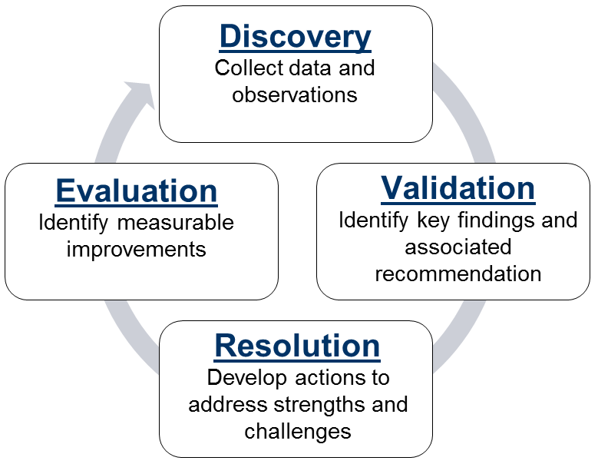
Figure 1: Example Figure

Potential Courses of Action
Desired Outcome: [Describe what the ideal organizational result of this scenario would be. Consider the goal we are trying to achieve. Using the same example about staffing levels, the desired outcome might be establishing clear understanding of the relevant office’s/program’s SOP on staffing.]
- COA 1: [COAs should include recommendations made by interviewees, program leadership or other technical experts, or a synthesis of different statements.]
- COA 2: [If unused, write “None” as a placeholder.]
- COA 3: [If unused, write “None” as a placeholder.]

Additional Validation Requirements
- [List ways to validate the information presented earlier. This may also include documents that were not used to draft this observation. Example documentation includes notes and/or summaries of interviews and hot washes.]

Conclusion
[Insert text summarizing the AAR and highlighting key points and next steps. Note that some information presented in this AAR may be outdated following publication. Current data on the status of corrective action implementation is maintained in the CIP Action Tracker. The CIP Coordinator is responsible for maintaining data in the CIP Action Tracker, which includes:

• Strengths, potential best practices areas for improvement, and innovations identified in the course of the event;
• The division responsible for corrective action development and implementation;
• The assigned point of contact;
• The corrective action or actions formulated by the point of contact; and
• The completion date of each corrective action
Once the corrective action is complete, the responsible division will evaluate its effectiveness in achieving specified goals.]

Improvement Plan
[List any areas for improvement and their associated corrective actions in Table 5.
Table 5: Areas for Improvement and Corrective Actions
Observation | Program Area | Area for Improvement | Strategic Goal | Potential Course of Action | POETE Element | Capability Element | Responsible Organization | Organization POC | Resources Needed | Start Date | End Date
Observation #1
Observation #2
Observation #3
Observation #4
Observation #5

Observation Components
The primary objective of this AAR was to determine the Strengths (STR), Potential Best Practices (PBP), and Areas for Improvement (AFI) observed by XX personnel during [XX incident]. Table 6 describes components of the observations in this document.
Table 6: Observation Components
Code | Description
Strength (STR) | Activities within policy or guidance that yielded better results than usual in a particular disaster. Strengths document processes or systems that are working and being implemented as intended.
Potential Best Practice (PBP) / Innovation | Activities not within policy that yielded better results than could have been expected from solutions within policy under the same conditions.
Area for Improvement (AFI) | Outcomes that did not meet expectations set out in plans, or the program did follow the process or system requirements, but the outcome was inadequate.
Innovation (INV) | Technological or procedural improvements to a process that resulted better outcomes.
Topic Sentence | The topic sentence should be the central thesis of the observation and contextualize the subject matter. The topic defines the area or category, such as Individual Assistance Housing Programs or Mitigation Assessment Teams that are the focus of the observation. The assertion is the action observed and expanded upon in the discussion. The impact is what occurred because of the action. The impact should drive the importance and priority of the action, and communicate how it affects the survivor, risk, cost, time, or other measurable elements. The consequence is why the topic and assertion matters.
Strategic Goals | Consider which of your agency’s Strategic Goal the observation supports. More than one Goal may be selected.  - Insert your goals here
Discussion | The discussion session should introduce what happened. It should also provide more detail of the problem, innovation, or process and support your observation with sources, examples, or other details. The writer should provide qualitative and quantitative evidence and analysis of the impact or the potential impact.  Additionally, the writer should explain why and how alternative theories could explain the same outcome. Consider what other factors could explain the capability gap XXX experienced and how someone else could interpret the evidence presented.
Desired Outcome | This is the ideal future state. It should consider the goal XXX will try to achieve or describe what success in addressing this observation would look like. (E.g.,“XXX assists in developing State capabilities to lead Housing missions after disaster events.”)
Courses of Action | These are recommendations provided primarily from interviewees, program leadership, or other technical experts, but may also be provided by the CIP team. (E.g., “Establish a procedure that validates state’s ability to lead a post-disaster mission confirmative with Threat and Hazard Identification and Risk Assessment (THIRA) standards before implementing an intergovernmental service agreement.”)
Information Needs for Headquarters Elevated Issues | Observations that cannot be resolved at the lowest level will be elevated to the agency and then to HQ as deemed appropriate by the agency. In the event an observation is elevated for HQ action, it is important the observation contains all of the information listed below. The following items should be included with each escalated observation:  - Follow the standard formatting found in the Observation Summary Template.  - Describe the scope of XXXs role within the process being observed.  - Identify relevant doctrine, policy, or procedures that currently exist that describe (or should describe) the practice or challenge observed.  - Describes systematic and appropriate analysis and interpretation of both qualitative and quantitative data.  - Recommendations clearly identify the organizational components that should be included in resolution.
Targeted Review | The observation will be socialized among the relevant programmatic components or operations elements within HQ for one week after the observation has been submitted to HQ.

Acronym List
AAR | After-Action Review
AFI | Area for Improvement
CIP | Continuous Improvement Program

Participating Organizations
[List all participating organizations of the event in Table 7.]
Table 7: Participating Organizations
Federal
[Participants]
State
[Participants]
County / Local
[Participants]
Private Sector / Non-Governmental Organizations
[Participants]

