Coding Guide
Following data synthesis and analysis, the collection team should have a good idea of high-level themes, or “buckets” that will serve as the building blocks for future observations. At this point, team members should begin the coding process.

Coding is the process of tagging, highlighting, arranging, or otherwise identifying data that supports high-level themes. Essentially, coding involves identifying pertinent information and moving it into the relevant “bucket” for each theme.

Coding will begin during collection efforts but should be continuously re-evaluated until collection efforts are complete and data analysis has been conducted. It is important to note that data synthesis, analysis, and coding are an iterative process. They begin during collection efforts and should be revised to incorporate new information until collection efforts are completed.

Data Coding
Data coding is an essential, but relatively simple process. The more familiar team members become with the information gathered during the collection phase, the easier data coding will be.
- Initial Coding: Code every concept
  - During the first round of coding, code/highlight every separate concept addressed in the notes.
  - Focus on becoming familiar with the content of the notes.
  - Keep this round basic and do not attribute feelings or connotations to the coded notes.
Following initial coding, team members can move into more focused coding.
- Focused Coding: Separate the data
  - During focused coding, categorize and separate coded concepts into strengths (STRs), areas for improvement (AFIs), potential best practices (PBPs), or mission critical (MC) issues.
  - Review the separated notes for significant/frequently used concepts.
The final stage in coding is to organize the data into high-level themes.
- Selective Coding: Organize the data
  - Describe high-level themes based off of the significant/frequently used concepts identified in the previous step.
  - Group the coded notes with the high-level theme that they support.
  - These focused data sets now serve as the basis for writing Observations.

Affinity Diagramming
One method to help with coding qualitative data is affinity diagramming. An Affinity Diagram is a tool that gathers large amounts of language data, such as interview notes, and organizes them into groupings based on their natural relationships. Affinity diagramming can be a useful way to aid the selective coding stage by creating and utilizing tangible and moveable data. To use an affinity diagram, follow the instructions below. The pictures are based on a study that looked at the usage of mobile calendars.

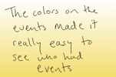
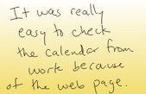
  - Step 1: Create affinity notes
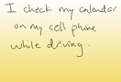
    - Write ideas on sticky notes
    - Each note should contain only one idea
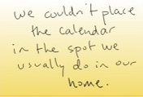
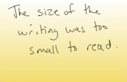

  - Step 2: Diagram building
    - Place notes on a large wall / surface

  - Step 3: Establish hierarchies
    - Group notes hierarchically (move into related columns) to see main themes
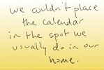


  - Step 4: Affinity labels
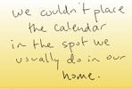
    - Write labels above each hierarchical group describing the group
People check when not at home
Placement is a challenge
Interface visuals affect usage

The affinity labels are the same as the high-level themes, and the notes are the associated coded notes.

http://www.balancedscorecard.org/portals/0/pdf/affinity.pdf

