Topic 9g: ARES Apparel

ARES Apparel

Student Preparation Required:

- None required for this Learning Unit.

Information

A long-standing public relations concern has been the lack of a unified, “branded” appearance of ARES volunteers in public service or emergency activities. While the American Red Cross and many other organizations have adopted recognizable, national standards of appearance, Amateur Radio chronically suffered from a wide variety of apparel - some of which was very poor indeed. Without an easily recognizable, standard “look,” the services of amateurs are easily overlooked by the public, media and civic leaders. There is a need for a standardized and consistent appearance by ARES volunteers which is easily identified, quickly spotted in a crowd, recognizable on TV and in photos, and adopted on a national scale.

While some clothing appear professional, a continuing plethora of Amateur Radio garb seen by the public wordlessly makes us appear to be amateurs in the worst sense of the word, undisciplined, fractioned and uncoordinated. A proposal for the ARRL to adopt a set of standards for ARES wear, which are to be worn when deployed in public service events or emergencies, was approved in January 2010. It includes standards for a mesh vest (hot climate use), standard vests and jackets. The standards can be met by many emergency clothing manufacturers and suppliers.

Plans are for a phased approach in which the new standards are the only new ARES clothing allowed while older, preexisting garb will simply be phased out by wear and attrition over 3 years. Adoption of these standards as THE ARES uniform clothing to begin being worn on deployments beginning summer 2010 and replacing all other items, is a major positive step in ARRL/ARES public relations.

ARES members, while activated, deployed or otherwise on duty shall wear over their normal apparel, at minimum, a florescent green ANSI Class 2 reflective, 100% polyester vest.

Vest Appearance - On The Back

Because the size of the printable space on vests can vary with the size of the vest itself, use the largest size Arial Black font possible up to 2" high lettering, black in color, imprinted above the horizontal reflective tape and centered in the back between any vertical reflective tape.

AMATEUR RADIO
EMERGENCY
COMMUNICATIONS

Those in a leadership position may add their title (SEC, DIRECTOR, EC, PIO, etc) below Emergency Communications in not less than 3" tall font, black.

Local jurisdictions may elect to add their organization name above Emergency Communications with no larger than 1" Arial Black lettering, color black.

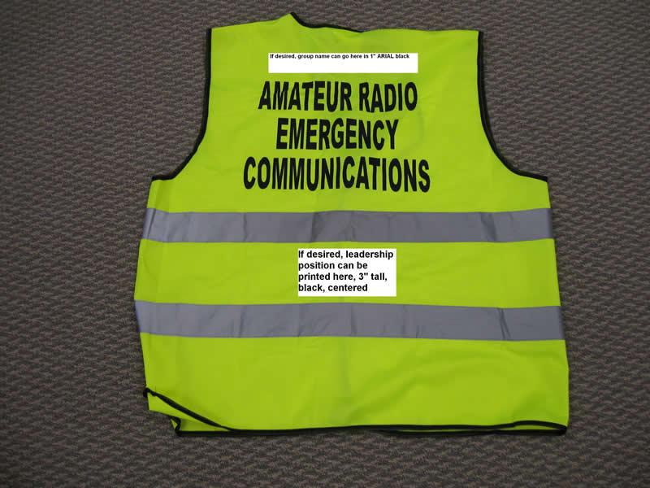

Vest Appearance - On The Front

On the Left Chest, the ARES logo, minimum 3 inch diameter, black in color, negative background.

The Right Chest shall remain blank so as to allow wearer to affix their ARES or ARRL name badge.

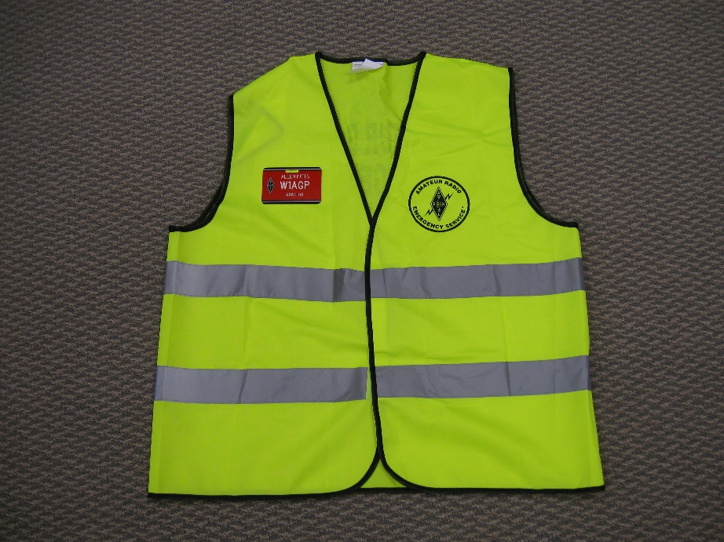

Vests may have zip or Velcro type front closures. Members may choose vests with or without pockets, at their own discretion.

Other Apparel

Other apparel, such as short and long sleeve tee shirts, jackets and coats are approved for member use as long as the garments meet the same color, ANSI Class 2, lettering and decoration standard.

A waiver of this standard may be given by an SEC for specific purposes with good cause.

Topic 9 Section G Knowledge Review

In order to demonstrate mastery of the information presented in the topic, you will be asked a series of un-graded questions. There are approximately 5 questions on the following pages in multiple-choice or true/false format. Feedback will be offered to you based on the answer you provide. In some cases, you may be directed back to the area of the topic where a review might benefit you in order to find the correct answer.

Question 1

The 2" lettering, above the horizontal reflective tape on the ARES deployment apparel shall say:

- AMATEUR RADIO
  - EMERGENCY
  - COMMUNICATIONS
- Radio
  - Communications
- Amateur Radio
- EMERGENCY RADIO
  - COMMUNICATIONS

Question 2

Members wearing approved ARES decorated apparel will enhance:

- Visibility to our served agencies
- Member safety
- Public familiarity
- All of the above

Question 3

ARES approved, decorated apparel shall be worn:

- during club meetings
- while on ARES duty
- on vacation
- All of the Above

Correct Answers
1 a
2 d
3 b

