Topic 8c: Building Relationships with Public Safety Agencies

Objectives

This topic unit will assist emcomm leaders in becoming aware of the unique needs in developing a relationship with public service agencies and how to build and enhance it.

Student Preparation Required:

- None required for this Learning Unit.

Course Background

The following lesson is based in part on a QST article written by veteran police officer and emergency management official, Jerry Boyd, N7WR. The information has been updated and supplemented for this course and discusses approaches to gaining the acceptance of police and fire department personnel.

Our Relationship

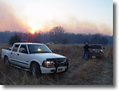
Amateur Radio Emcomm volunteers arrive
at the Fox Den wildfire in southern Oklahoma

Public service communications provided by ARES members are based on a number of requirements. Specifically, public-safety officials first must accept us. Once accepted, our continued ability to contribute in times of disaster is based on the efficiency and effectiveness of our ongoing performance. While acceptance, image, efficiency and effectiveness are all important to the ongoing working relationships between radio amateurs and officials, it is the initial acceptance that is often most difficult to achieve.

How Public Safety Officials See Volunteers

Police and fire officials tend to be very cautious and skeptical concerning those who are not members of the public-safety professions. This posture is based primarily on experiences in which well intended but somewhat overzealous volunteers have complicated, and in some cases jeopardized, efforts in emergencies. The amateur operator or other volunteer who wants to be of assistance must be aware of this bias. The police have generally had their fill of “hangers-on.” They cannot afford to tolerate frustrated individuals who have always wanted to be police officers or firefighters, but for one reason or another have never reached that goal. There seems to be an abundance of people, especially during a crisis, who will quickly overstep the limits of their authority and responsibility if they are given any opportunity to assist in an official capacity. In their zeal, such persons often disrupt the actions of trained personnel. Worse yet, they can make an already dangerous situation even more so by their actions. With few exceptions, Amateur Radio operators do not fall into this category. The problem is, however, that police officers in the midst of stressful operations may have difficulty in distinguishing between those volunteers who are problem solvers and those who are problem makers. For this reason outward appearance is paramount. Amateur Radio operators need to present themselves in a professional manner both in dress and appearance and by conducting themselves in such a way as to gain the confidence of the served agency.

Those very few amateurs that behave badly, are overzealous in offering their services or in describing their abilities, or who abuse the established limits of their responsibility, are doing the Amateur Radio fraternity a real disservice. The typical police officer or firefighter, like the typical civilian, does not understand the vast differences among various radio services, the types of licensing involved or the high level of expertise and discipline that is characteristic of the Amateur Radio Service.

Remember when you are pressed into service, YOU represent all of Amateur Radio in the eyes of those officials at the served agency. For example:

If an Amateur Radio operator arrives at a scene and jumps out of a vehicle with a hand-held radio in each fist and two more clipped to the belt, all squawking at once, officials simply don’t know how to respond. They are either overwhelmed by equipment they do not understand, or so awe-struck that they try to avoid what they perceive as threatening.

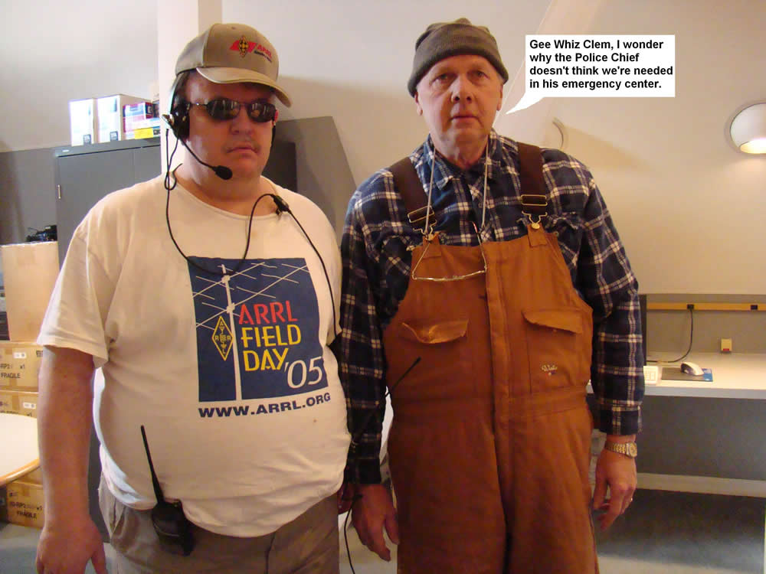

Working To Become Accepted

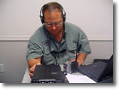
Steve Jax, N4SJJ operating 6 m SSB in his role as liaison to the local government
agency for Polk County, FL with Polk County Emergency Services.

How Amateur Radio volunteers are accepted depends on their establishing a track record of competent performance in important activities. This begins with convincing officials that ARES and Amateur Radio operators can offer a cost-effective (otherwise known as “free”) substitute for functions that would otherwise be unmet needs or paid for by taxpayers. Local radio amateurs also must demonstrate that they are organized, disciplined, reliable, have a sincere interest in public service, and the capability to provide the types of services needed by the agency. Establishing a dialogue with your served agencies in advance of an emergency can provide a foundation for future relationships. As time progresses, and a bond of trust is established, a long-term relationship emerges that must continue to be fostered.

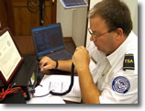
Groups such as MARS teaming with the federal Transportation Security
Administration work productively to assist with emergency communications.

The most effective way to accomplish this is for you, as head of your communications group, to initiate the contact with public safety agencies in an official capacity. This is far better than having individuals, particularly coming from outside an organized structure, making uncoordinated and poorly prepared contacts that often result in an impression that Amateur Radio is completely disorganized.

Approach the first meeting well prepared, and give a concise presentation of Amateur Radio’s capabilities. Aids to making presentations can be found at www.arrl.org/media-and-public- relations. Additional help is available at www.arrl.org/public-service.

Be careful not to oversell your actual capabilities. Often it is effective to have a team of ARES leadership be present. This could include the SEC, DEC and a local EC depending on the situation. Illustrate accomplishments with newspaper clippings, QST and other magazine articles, etc., highlighting Amateur Radio's proven history of public service. Discuss the existing Amateur Radio structure, emphasizing that a certain number of qualified operators will be able to respond to the public’s needs. Be conservative in your estimates.

Demonstrate the reliability and clarity of Amateur Radio equipment. Nothing is more impressive than asking for a roll call on a 2-meter repeater using a hand-held radio in the police or fire chief’s office and having immediate responses with full-quieting signals from locations where municipal radios are normally ineffective. Such a demonstration several years ago convinced officials in Laguna Beach, California to ask for the assistance of the South Orange County ARES. The wisdom of this decision became evident a short time later when that seaside resort community was hit by a series of local emergencies. If your section has an IRLP system in place, check-ins from far away points may also demonstrate wide coverage that may be needed should an agency’s system fail.

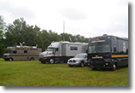
State communication vehicles at the May 2009 communications training
exercise sponsored by the Alabama Dept. of Homeland Security.

Suggest specific ways in which radio amateurs can be of assistance. Indicate that you are aware that police and fire radio frequencies are usually saturated with critical tactical or operational traffic during emergencies, and offer to provide a staffed administrative frequency for use in coordination of the relief effort. More important, offer to demonstrate what you are actually capable of doing by supplying a demonstration of your communications capabilities. It is of tremendous importance that you emphasize that the services supplied by your group could free up public-safety personnel for other duties.

Demonstrate how easily Amateur Radio operators and their equipment can interface with public-safety efforts. A perfect way to do this is to demonstrate equipment that can be made operational quickly inside the headquarters building, in a mobile command post or in field units.

Express your group’s willingness to meet the needs of the agency but
do not raise false expectations

Ask about their needs, and show a readiness to provide training to your membership in meeting these needs. Offer public-safety officials the opportunity to have their own representatives appear before your group and provide orientation and training they feel is essential.

Finally, be realistic and objective in terms of what your group promises to provide. Be fully prepared to keep all promises you make. Remember to be organized and competent. Once you have implemented these suggestions, be patient. The requests for your services will be forthcoming, perhaps in a volume you had not anticipated!

Grass-roots action is the name of the game when it comes to achieving effective liaison. With the proper groundwork accomplished in advance, recognition among those sponsors and agencies having communications needs can be dramatically increased. It’s symbiotic; these people need us, and we want to help.

References

For more information on any of the elements presented, please consult the following link:

- ARRL Manual:
www.arrl.org/ares

Review

The behavior of ARES members and their approach to served agencies is critical if they are to be accepted by agency professionals. Most are wary of volunteers, often with good reason. ARES groups should present a unified and professional front at all times. “Free-lancing” by individuals should be strongly discouraged.

Student Activities

- Prepare a presentation outline you could use in talking to public safety leaders about your own group.

Topic 8 Section C Knowledge Review

In order to demonstrate mastery of the information presented in the topic, you will be asked a series of un-graded questions. There are approximately 5 questions on the following pages in multiple-choice or true/false format. Feedback will be offered to you based on the answer you provide. In some cases, you may be directed back to the area of the topic where a review might benefit you in order to find the correct answer.

Question 1

Once an emcomm group has been accepted by an agency, which of the following is true?

- The group’s continued ability to work effectively with the agency is based upon the resources the group brings to the task.
- The group’s continued ability to work effectively with the agency is based upon the group’s ongoing performance.
- The energy level and interest of the group’s members decreases at their annual meeting.
- The ability of key members of the group to take over the served agency increases.

Question 2

Which of the following represents the best way for emcomm group members to maintain a good relationship with a served agency?

- Occasionally overstep the limits of the group’s authority.
- Frequently overstep the limits of the group’s authority.
- Never overstep the limits of the group’s authority.
- Ignore all limits of the group’s authority in getting the job done.

Question 3

In selling your emcomm group’s services to an agency, which of the following actions is inappropriate?

- Be realistic in what your group promises to provide.
- Be patient with the agency and its decision processes.
- Express you willingness to meet the needs of the agency.
- Dazzle agency representative with your knowledge of technical terms, concepts and equipment.

Question 4

Regarding the perceptions of police and fire officials, which of the following is false?

- They tend to be cautious and skeptical about individuals who are not members of the public safety community.
- They always appreciate the efforts of volunteers.
- They are concerned about volunteers who might overstep the limits of their authority.
- They are wary of zealots who may disrupt the actions of trained personnel.

Question 5

Of the following statements, which is most likely to have a positive impact on a served agency?

- Each group member possesses a two-meter HT radio with backup batteries.
- Group members wear distinctive shoulder patches on their jackets.
- The group consists of operators with an average of eight years of Amateur Radio experience.
- The services supplied by your Amateur Radio group can free public safety officers for other duties.

Correct Answers
1 b
2 c
3 d
4 b
5 d

