Topic 7: Digital Options in Message Handling

Objectives

Welcome to Topic 7. After completing this topic, the student will be able to appreciate the scope of amateur digital communications as they exist today.

Student Preparation Required:

- None required for this learning unit

Analog Emergency Communications

Analog emergency communications have been the mainstay of Amateur Radio from the beginning; but how long can it last?

Amateur analog radio communications have been the mainstay of the “when all else fails” concept. In other words, when complex digital systems go offline during emergencies, we’re there with our reliable good-old-fashioned analog radios. But how long can our analog advantage last? With the rapid penetration of digital communications into our everyday lives, we’re also seeing digital systems designed specifically for emergency applications. When Hurricane Katrina swept a path of destruction through the Gulf Coast states in 2005, cellular telephone companies were on the scene within 24 hours in some places, using portable cell nodes to replace lost towers. At the same time, other companies and government agencies were setting up portable, satellite-based Internet hubs. While Amateur Radio played a critical role during Katrina and elsewhere, experts agree that our historical role is changing as portable “hardened” digital communication systems become more widespread.

Welcome To The Digital World

Amateur digital radio communication has evolved rapidly during the last five decades, and especially so within the last decade. If we exclude CW, from the end of World War II until the early '80s, radioteletype, better known as RTTY, was the only digital mode available to amateurs for emergency communications. Then, in 1983, AMTOR made its debut, coinciding with the rising popularity of personal computers. AMTOR was the first amateur digital communication mode to offer error-free text transmission and it was primarily used on the HF bands. This evolution greatly increased the capabilities of emergency communicators to pass traffic with no errors, thus allowing an increase in their capability to serve the disaster organizations.

With AMTOR's debut, the rate of change quickened. Packet radio emerged by the middle '80s and, for a time, reigned as the most popular form of amateur digital communication. As microprocessor technology became more sophisticated we saw the rise of modes such as PACTOR that were capable of error-free exchanges under marginal band conditions (weak signals, interference and so on). In the late '90s there was an invention that harnessed personal computer sound cards to create a new digital mode for casual operating: PSK31. In the first decade of the 21st century the evolution has continued with more digital modes such as D-STAR. And Winlink 2000 has emerged, providing standard email capability in emergencies even when portions of the Internet are down. All of these modes over the years have allowed the Amateur Radio emergency communicators to increase their capability, flexibility, and applicability in the emergency communications field.


Phil Kamas, KE3FL is active on the Maryland Emergency Phone Net
as well as the Carroll Amateur Radio Emergency Team.
Let's take a brief look at a few of the main digital communication modes common to Amateur Radio in the USA and where they stand today.
Want to HEAR what these modes sound like? Go to www.sigidwiki.com/wiki/Signal_Identification_Guide

RTTY

RTTY is the granddaddy of HF digital, although its popularity has been seriously undercut by PSK31 (more about PSK in a moment). RTTY still sees considerable use on the HF bands for contesting and DXing.

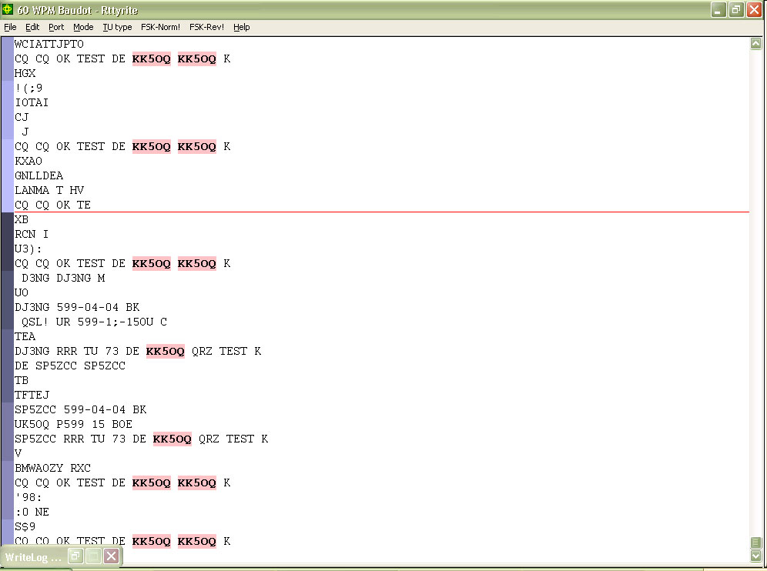

Figure 7.1: RTTY is still used today for digital contesting and DXing.
AMTOR

Amateur Teleprinting Over Radio--AMTOR--enjoyed widespread popularity from about 1983 through 1991. AMTOR has since been superseded by faster, more versatile modes. It is rarely heard on the ham bands today.

PACKET

Although packet technology had been in existence since the early '70s, Amateur Radio operators embraced it with gusto in the middle '80s. (Personal computers, again, were the driving force.) Packet is an error-detecting mode, which means that it is capable of communicating error-free. For nearly a decade packet flourished, primarily on the 2-meter band. But as the Internet skyrocketed to prominence, traditional packet declined just as rapidly. Bulletin board stations closed, many networks collapsed and sales of packet equipment slowed to a trickle.

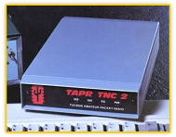
Figure 7.2: The TAPR TNC-2 ushered in the era of amateur packet radio.

VHF packet retains a foothold today thanks to DX spotting networks (known as DX PacketClusters) and the popularity of the Automatic Position Reporting System (APRS), a marriage of amateur packet radio and global positioning satellite technology. VHF packet radio also sees activity in emergency communications.

Packet radio networks are essential to providing coverage over wide areas, especially on VHF. To learn more: www.ampr.org/

PACTOR

PACTOR appeared in 1991. It combined aspects of PACKET (the ability to pass binary data) and the robust error-free nature of AMTOR. It became the number-one HF digital communication mode but, as with packet, the Internet caused a serious decline in PACTOR activity. Still, it remains the most popular of the HF error-free modes.

PACTOR II

PACTOR II debuted in the mid '90s and an even more enhanced version known as PACTOR III appeared by the year 2000. PACTOR II and III find their greatest use in the HF portion of Winlink2000, a network that provides the ability to transfer e-mail to and from the Internet, using radio to skip over portions of the Internet that are down. The VHF portion of Winlink2000 relies on packet radio access, and can also provide “last mile” email (with attachments) communications when local Internet access has been compromised.

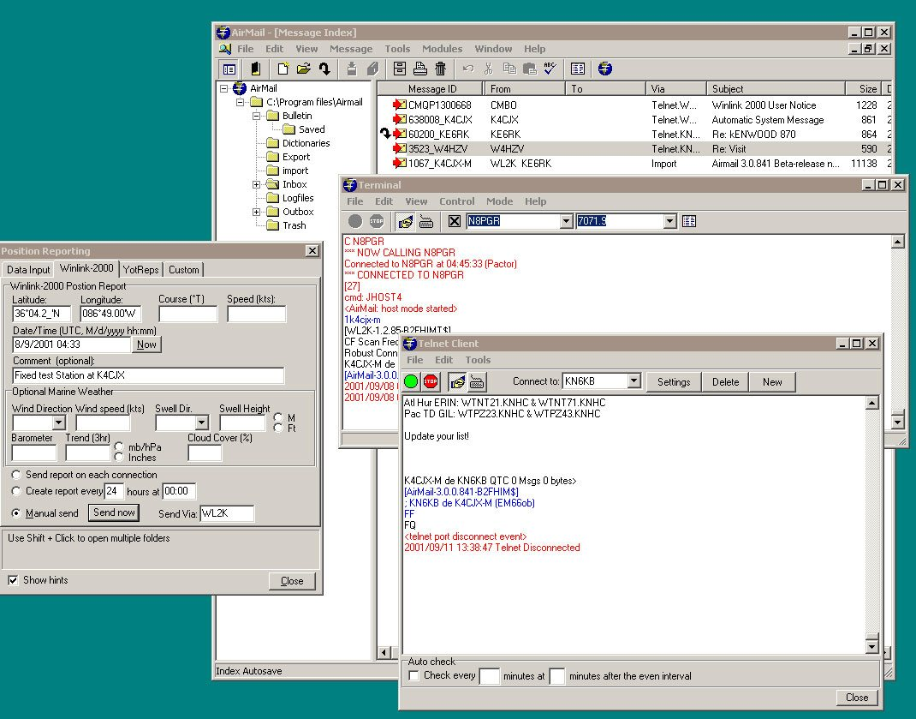
Figure 7.3: Using AirMail software in this example, Winlink2000 allows
amateurs to send and receive Internet email from any location in the world.
PSK31

PSK31 could be viewed as a high-octane cousin of RTTY. It is not an error-free digital mode, but it offers excellent weak-signal performance. Peter Martinez, G3PLX, the same person who created AMTOR, invented PSK31.

In 1999 Peter designed a version of PSK31 that needed nothing more than a common computer soundcard. Interest in PSK31 exploded when the "panoramic" transceiver concept was introduced a year later with DigiPan and similar software. PSK31 is now the most popular HF digital mode for keyboard-to-keyboard conversations.

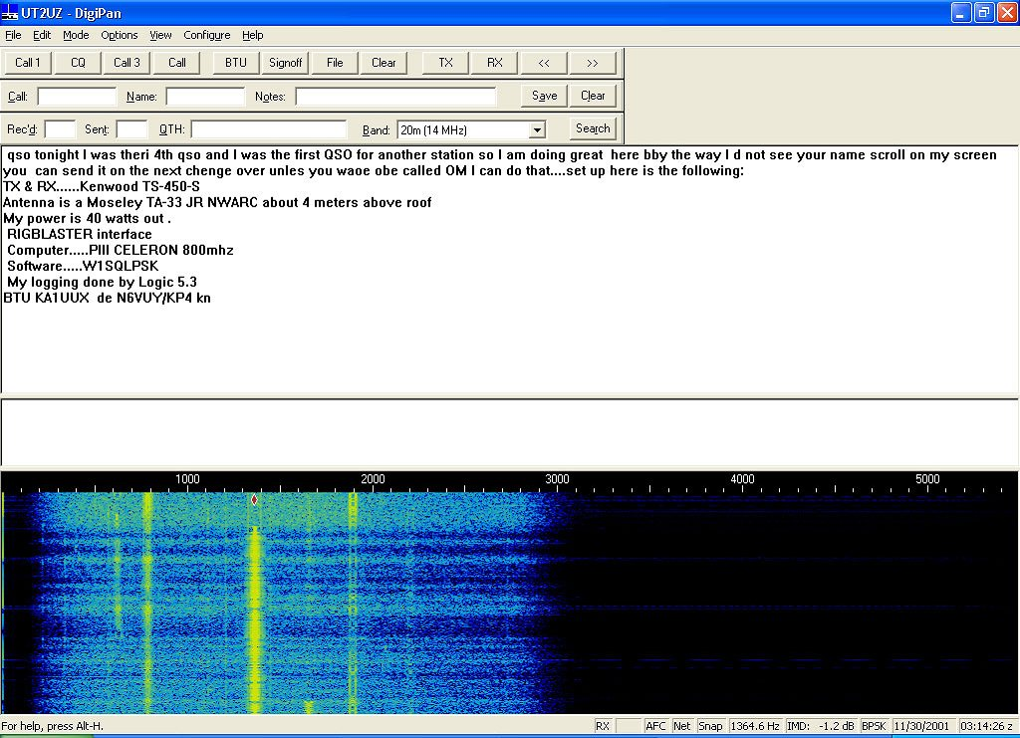
Figure 7.4: DigiPan software in action. Each vertical line in the display represents a PSK31
conversation. To monitor a conversation, you simply click your mouse cursor on one of the lines.

APRS™

The Automatic Position Reporting System, better known as APRS, was the brainchild of Bob Bruninga, WB4APR. In fact, APRS is a trademark registered by WB4APR. Some refer to APRS as the Automatic Packet Reporting System, and either description is valid because although most Amateur Radio operators use APRS to track moving objects, it is also capable of functioning as a broader-based communications network. If you intend to track the movements of an object, it stands to reason that you must have a wireless means of receiving information that defines its position, specifically latitude and longitude coordinates. Mobile APRS stations transmit their position information in the form of packet radio beacons. Receiving stations use APRS software to decode these beacons and display station positions as icons on colorful maps. As a receiving station picks up new position information from a particular station, it updates the position of its icon on the map. By clicking your mouse cursor on the icon, you can see more information that’s also included in the APRS packet, such as speed, direction of travel, etc. As you can imagine, the ability to track objects in motion is a huge asset to emergency communications. APRS stations can also inject short messages into Winlink 2000 networks, where they can enter and travel on the Internet.

Virtually all APRS activity takes place today on 144.39 MHz using 1200-baud packet TNCs and ordinary FM voice transceivers.

You will need a radio for sure, but other pieces of the system depend on your goals. The critical component of your APRS station is software. You’ll need software to display the positions of APRS stations, along with other information contained in their transmissions. Since most amateurs use Microsoft Windows on their station computers, the most widely used APRS software is written for Windows. At this time the most popular APRS Windows program by far is UI-View (www.ui-www.ui-view.net/). UI-View was created by the late Roger Barker, G4IDE. The 16-bit and 32-bit versions are free downloads. A donation to the charity of your choice is recommended with the registration of the 32-bit version. Note, however, that APRS software is not necessary for mobile stations that wish to merely transmit APRS beacons for tracking purposes. That function is carried out automatically using a GPS receiver and APRS- compatible TNC or tracking device; it does not depend on software. And, if all you want to do is monitor APRS activity, you do not need a GPS receiver.

If you want to participate in the local APRS network from a fixed (non-moving) station, such as an emergency operations center, you still do not need a GPS receiver. Just determine your latitude/longitude coordinates and you can use them to establish the location of your station on the network. You enter the latitude/longitude information into your APRS software and then select an appropriate icon that will
appear on maps at receiving stations.

Igate

Igate is a way to post APRS™ information to a web site accessible by anyone. This ability can come in handy when you want others outside the emergency area to be able to monitor operations. Anyone can use these lookup sites (FCC license not required for looking), so all you have to do is give them the Web URL and tell them to enter your callsign in the query field. However, this assumes that digipeaters in the emergency zone are able to relay to an active IGate station. Depending on the scope of the disaster, this may not be the case. But when it can be done, it is most impressive!

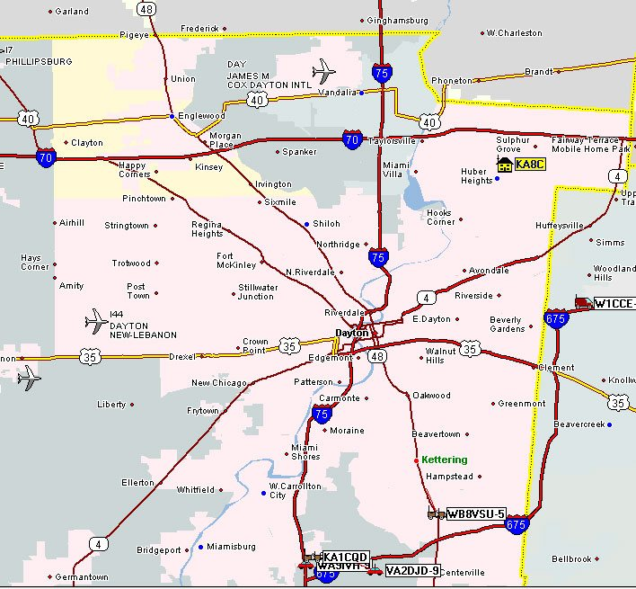
Figure 7.6: APRS™ allows easy tracking and position reporting - and information
can be posted to Internet for others to see.
D-STAR

The D-STAR digital protocol was born in 2001 as a project funded by the Japanese Ministry of Posts and Telecommunications to investigate digital technologies for Amateur Radio. The research committee included representatives from the major Japanese Amateur Radio manufacturers, including ICOM, and the Japan Amateur Radio League (JARL). The JARL ultimately published the final version of the protocol.

All radio manufacturers are free to develop D-STAR equipment, but at the time of this writing ICOM is the only company that has done so for the US amateur market. Because of this fact, amateurs tend to associate the D-STAR digital protocol with the ICOM Corporation. Although ICOM may develop D-STAR protocol enhancements peculiar to the function of its hardware, ICOM does not “own” the original D-STAR protocol.

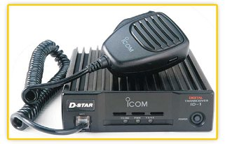
Figure 7.5: The ICOM ID-1 D-STAR transceiver.

D-STAR can be used for digital voice and data communications. Most D-STAR activity is on the 2-meter, 70-cm and 23-cm bands.
Like Winlink 2000, D-STAR networks offer data communication over wide areas, including possible "last mile" solutions for providing Internet access to served agencies within disrupted areas.
A misconception about D-STAR is that it is strictly a digital voice system. The primary application of D-STAR is indeed voice, but it is a system capable of handling any sort of data—text, voice, images, etc.

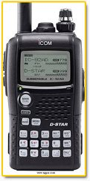
Fig 7-5C: D-STAR handhelds allow analog voice, digital voice and
low speed text options for roving units.
A D-STAR network can take several forms. D-STAR compatible transceivers can communicate directly (simplex), or through a D-STAR repeater for wide coverage. But note that D-STAR digital signals cannot be repeated through traditional analog repeaters. D-STAR repeaters, in turn, can link together to form a backbone. This linking can take place with RF (microwave) or by way of the Internet.
Note that D-STAR's digital signals cannot be repeated through traditional analog repeaters.

At this time a few analog repeaters have been modified to repeat D- Star GMSK transmissions, but they are NOT considered D-Star repeaters

The D-STAR system carries digitized voice and digital data, but does the job in two different ways. There is a combined voice-and-data mode (DV) and a high-speed data-only stream (DD). From the perspective of the D-STAR user, data and voice are carried at different rates and managed in different ways. Along with the digitized voice information, D-STAR’s DV mode can also carry 8-bit digital data at 1200 bps and can do so simultaneously. D-STAR's high- speed data mode is called D-STAR DD and is only available on 1.29 GHz. The data-only packets are sent over the RF link at a raw data rate of 128 kbps, half duplex. The DD mode interface looks to computer equipment just like a customary network connection. Specifically, the DD mode interface is an Ethernet "bridge" between a pair of fixed network addresses. This allows Web browsers and other Internet software to run normally, as if they were connected to a standard computer network.
The net data rate of DD mode is comparable to or better than a high-speed dial-up Internet connection. Any streaming media mode that will run over dial-up Internet will likely perform well over D-STAR, too. With its high signaling rate at 130-kHz bandwidth, FCC regulations restrict D-STAR DD operating to the 902 MHz and higher bands.

In emergency communication applications, the DD mode would prove useful in setting up a local network, perhaps between nearby facilities. It is also possible to operate in the DD mode over a much longer link, perhaps to a point outside the disrupted area where an Internet connection still exists to pass e-mail traffic. Remember, however, that the DD mode can only be used at 902 MHz and above. This means that you’ll need UHF or microwave RF power amplifiers and directional antennas at elevated positions with clear paths between stations. This may be difficult to achieve in urban areas or over hilly terrain.
The coverage solution is the D-STAR repeater, assuming there are D-STAR repeaters operating in the area. Cost is definitely a factor when considering D-STAR. An ICOM D-STAR transceiver capable of operating in the DD mode can cost more than $1000. DV-capable ICOM transceivers cost approximately $400-600, although several less expensive ICOM analog FM transceivers can become DV radios with the addition of the $200 UT-118 module. The cost of building a D-STAR repeater (exceeding $4000 in many instances) has had the effect of slowing deployment, but several Amateur Radio groups have turned to Department of Homeland Security grants and local government funding to establish these systems.
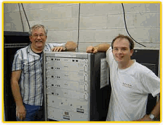
Fig 7-5A: A full D-STAR repeater system has several modules.
It is important to understand what D-STAR systems cannot or may not do, due to both technical and regulatory restrictions.

D-STAR uses many techniques that are derived from or seem similar to those of the mobile phone systems and the Internet. Nevertheless, D-STAR does not create a "Ham Radio Cell Phone" or an "Amateur Radio Internet." Most importantly, D-STAR communications are public and can be monitored by anyone with a D-STAR radio or a receiver capable of decoding D- STAR signals.

Streaming media are also quite constrained by D-STAR’s limited data rate. Anyone expecting to watch video or download music via a D-STAR DD mode connection will likely be disappointed. D-STAR supports reasonable amateur requirements, but is not a contending replacement for a broadband Internet connection to watch YouTube.

Amateur Radio operators using D-STAR’s DD mode can certainly connect to the Internet, send and receive e-mail, use FTP servers, and so forth. Nevertheless, the FCC’s prohibition against using Amateur Radio for commercial purposes still applies. This means that D-STAR users and system owners must be vigilant in keeping the many commercial aspects of the Internet off of the D-STAR system.

D-STAR’s primary benefits in emergency communications are the ability to instantly identify calling stations and to selectively call individual stations on the same frequency. If stations have computers connected to their D-STAR transceivers, they can also exchange text data in the low-speed DV mode, which all D-STAR radios support. So, the same radio that you might use to communicate by voice can also communicate text data—often at the same time.

If stations have computers connected to their D-STAR transceivers, they can exchange text data in the low-speed DV mode, which all D-STAR radios support.

So, the same radio that you might use to communicate by voice can also communicate text data—often at the same time.

APCO25

The APCO25 digital standard was developed specifically for local, state and federal public safety communications. The goal was to create a digital communications standard that would allow total interoperability. That is, the ability for one agency to easily communicate with another despite owning different equipment.

Because it is an open, published standard, APCO25 is legal for Amateur Radio use. Amateur APCO25 activity is primarily found on the 2 meter and 70 cm bands. Since there are currently no APCO25 transceivers being manufactured for the Amateur Radio market, amateurs use modified commercial transceivers. The trick is finding the means to adapt commercial APCO25 gear to our purposes.

Amateur Radio APCO25 enthusiasts today are treading the same path taken by analog FM pioneers more than 30 years ago. They are modifying commercial APCO25 equipment for Amateur Radio and setting up APCO25 repeater systems. Thanks to online sites, it is relatively easy to find surplus APCO25 transceivers. Manufactured in both handheld and mobile configurations, these rigs are available for either VHF or UHF.

Modifying commercial APCO25 radios has become a software programming game. Since most functions of these radios are software defined, you can change their operating characteristics (including frequencies) with a computer and a compatible interface.

Unlike D-STAR, which is a digital standard devised by and for Amateur Radio, APCO25 was developed specifically for local, state and federal public safety communications. "APCO" is the Association of Public Safety Communications Officials, originally an association of police communication technicians, but now a private organization. APCO has a technical standards group responsible for planning the future needs of police (and more recently public-safety) users. It was through this group that a standard for advanced narrow-band digital communications (voice or data) was developed. This standard is known as APCO Project 25, APCO25, or simply P25. APCO25 is comprised of a "Suite of Standards" that specifies eight open interfaces between the various components of a land mobile radio system. You’ll find more details about the APCO25 standard at:

http://apcointl.org/spectrum-management/resources/interoperability/p25.html

The overall purpose of the APCO25 standard is to make it possible for government organizations to shift from analog to digital communications with the least difficulty possible. This means placing a great deal of emphasis on backward compatibility (P25 radios include analog operation and newer P25 technology doesn’t render older technology instantly obsolete) and interoperability (the ability for all P25 radios to communicate with each other).

In the public safety world, interoperability is a key selling point. The chaotic communications experience in New York City during the September 11, 2001 terrorist attack and in 2005 during Hurricane Katrina demonstrated the critical importance of interoperability. During both disasters there were numerous instances where radio communication between various groups was impossible because each group was using mutually incompatible equipment.

EchoLink, IRLP, and WIRES II (VoIP Routes)

While we certainly have the capability to span continental distances on the HF bands, that ability can be hampered by the vagaries of propagation, making it somewhat unreliable. HF links almost always also require large antennas and substantial hardware and power requirements—more than a basic VHF FM transceiver. By using Internet links instead, an Amateur Radio operator with a modest radio (even a handheld transceiver) can reliably communicate with stations hundreds or even thousands of miles away at any time of the day or night. Of course, this assumes that the radio signal can reach a point where Internet access is still available.

Amateur Radio public service groups have used EchoLink, IRLP and WIRES-II in a variety of applications. Perhaps one of the best known is the VoIP SKYWARN/Hurricane Net, or simply VoIPWX at www.voipwx.net.

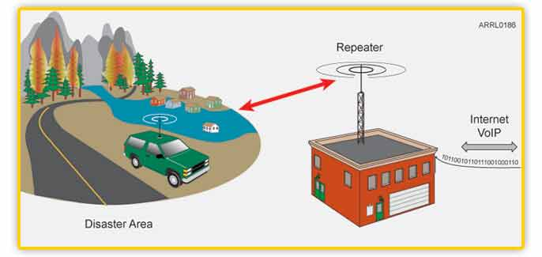
Figure 7-7 If a station in a disaster area can reach a repeater with a VoIP Internet connection; it is
possible to establish reliable communication to almost any point on the globe.

The most common form of Internet linking by Amateur Radio operators involves the exchange of audio using VoIP—Voice over Internet Protocol—technology. This is the same technology used by Internet telephone services, and by online voice “chat” applications such as Skype, TeamSpeak and others.

Three versions of Amateur Radio voice linking have become popular in the United States during the past decade: EchoLink, IRLP and WIRES-II. Descriptions and examples of these are presented on the following pages.

EchoLink

EchoLink is the brainchild of Jonathan Taylor, K1RFD. His EchoLink software is designed for Windows PCs, but there is a Mac version as well. With the software installed on a sound-card- equipped computer, any licensed radio amateur can create an EchoLink node that others can access by radio. Licensed Amateur Radio operators can also join the network directly without using radios. They simply plug microphone/headsets into their computers.

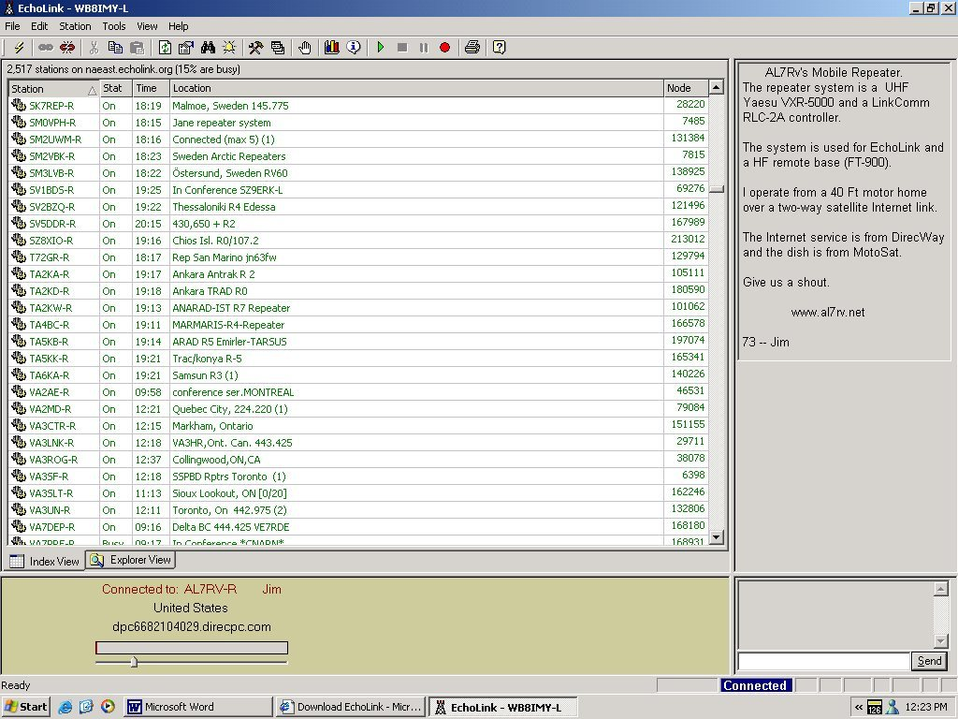
Figure 7.7a: EchoLink software running under Windows Vista.

Every Amateur Radio operator who establishes an EchoLink node, or who connects to the network directly, must be validated, which means providing positive proof of identity and current license before being granted access. After having been validated, each EchoLink node or user must provide a password, along with his or her callsign, to log in. Each time a connection is made for a QSO, the EchoLink servers verify both the sender and the receiver before communication can begin. Amateur Radio operators who use their radios to connect to the EchoLink network through a repeater or a simplex node do not have to be validated or provide a password, etc. This is only necessary for the repeater or link stations, or for those who connect directly via computer.
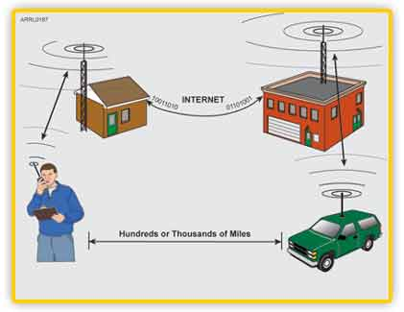
Figure 7-7b: The Internet VoIP link allows repeater users to speak with other
Amateur Radio operators who may be transmitting through other repeaters.

IRLP

IRLP stands for Internet Radio Linking Project. Like EchoLink, IRLP uses the Internet to establish VoIP links. The difference is that IRLP only permits access via RF nodes at repeaters or on simplex frequencies (all IRLP nodes are interlinked via a central Internet server). You must use a radio to access the IRLP network.

WIRES II

WIRES-II--Wide-Coverage Internet Repeater Enhancement System--is a VoIP network created by Vertex Standard (Yaesu). It is functionally similar to IRLP (including management via a central Internet server), but nodes and repeaters are connected via a Vertex Standard HRI-100 interface and a computer running under the Windows operating system. Vertex Standard transceivers are not required for WIRES-II communication, but as with IRLP, all access must be via RF.
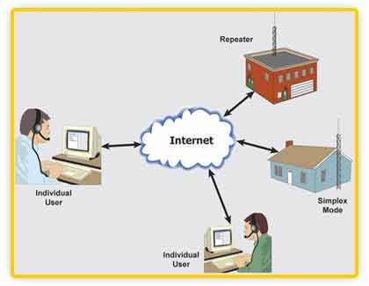
Figure 7-7c: Three versions of Amateur Radio voice linking have become popular
in the United States during the past decade: EchoLink, IRLP and WIRES-II.

Digital Communication: Pros and Cons

Anything digital receives instant attention in the technical press these days. This is understandable since nearly all communication—wired and wireless—is moving to digital formats. Even broadcast TV went digital in 2009. We’re witnessing the emergence of an all- digital world where Internet access will be ubiquitous through wireless devices of every description. Content will be truly multimedia with text, sounds, images and video available on demand--anytime, anywhere.

Where does that leave Amateur Radio?

When it comes to Amateur Radio, we are well behind the digital technology curve. Roughly 90% of all routine Amateur Radio communication is analog: AM, FM, SSB and CW (although you can certainly make the case that CW is digital communication, after a fashion).

Being a mostly analog communication service is not a bad thing. The strength of analog is that it is simple and reliable. The process of sending and receiving an analog signal is relatively straightforward. Better still, the encoders and decoders are human beings. Someone speaks into a microphone or taps a code key. At the receiving end, another person listens and instantly decodes—even under conditions that would render most digital modes useless.
However, many of the agencies we serve are already beginning to ask about our digital capabilities…

- “Can you transfer detailed printed supply lists or personnel assignments between sites?”
- “Can you get critical e-mails to the Internet if our connection goes down?”
- “Can you relay digital images of damage at specific locations?”
- “Can you track the locations of our personnel and display them on computer maps?”

When the agency you serve asks questions like these, you’ll want to be able to reply with more than a blank stare!

Review

In this Topic, you have received a basic overview of the state of common Amateur Radio digital communications in emergency use today, and our potential role in the future.

Student Activity

Student Activity:

- Consider the modes that do and do not have forward error correction or other ways to assure that their transmissions are correctly received. Match these modes' utility in deployments and activities in which you have participated in the past. Which ones could have worked out well? Why - or why not?

Topic 7 Knowledge Review

In order to demonstrate mastery of the information presented in the topic, you will be asked a series of un-graded questions. There are approximately 5 questions on the following pages in multiple-choice or true/false format. Feedback will be offered to you based on the answer you provide. In some cases, you may be directed back to the area of the topic where a review might benefit you in order to find the correct answer.

Question 1:
Which digital mode came into use immediately after World War II?
- RTTY.
- PSK31.
- AMTOR.
- Packet.
Question 2:
Today, PACTOR is primarily used for the HF portion of what global network?
- INMARSAT.
- WinLink2000
- G-TOR
- APRS™
Question 3:
Which radio manufacturer is allowed to produce D-STAR compatible equipment for sale in the United States and elsewhere?
- ICOM.
- Kenwood.
- Yaesu.
- Any manufacturer can produce D-STAR compatible equipment.
Question 4:
What is one advantage of digital communications in an emergency?
- Inexpensive equipment.
- Loud audio.
- The ability to transfer text and images.
- Lighted buttons on transceivers.
Question 5:
What does “APCO” stand for?
- Association of Public Safety Communications Officials.
- American Packet-safety Communications Organization.
- Advanced Public Consortium of Officials.
- Associated Protocol Consortium Organization.
Question 6:
What is VoIP?
- Voice over Internet Protocol.
- Voice operated Internet Protocol.
- Voice over Internet Passband.
- Voice operated Inband Protocol.

Correct Answers
1 a
2 b
3 d
4 c
5 a
6 a

