EMERGENCY COORDINATOR

FSD-3 ARRL Numbered Radiograms

http://www.arrl.org/files/file/Public%20Service/fsd3.pdf

FSD-46 EC Guidelines

http://www.arrl.org/emergency-coordinator

FSD-88 Notification of Appointment Letter

FSD-98 ARES Registration Form
http://www.arrl.org/files/file/Public%20Service/fsd98.pdf

FSD-157 Public Service Activity Report
http://www.arrl.org/fsd-157-public-service-activity-report

FSD-210 Appointee Monthly Report Card
http://www.arrl.org/public-service-field-services-forms

FSD-212 EC/DEC Monthly Report Card
http://www.arrl.org/public-service-field-services-forms

FSD-218 Amateur Message Form
http://www.arrl.org/files/file/Public%20Service/fsd218.pdf

FSD-220 Time Conversion

http://www.arrl.org/files/file/Public%20Service/fsd220.pdf

FSD-224 ARES Membership Cards
Available from Headquarters

“ARES Manual” Amateur Radio Emergency Service (March 2015)
http://www.arrl.org/files/file/Public%20Service/ARES/ARESmanual2015.pdf

http://www.arrl.org/ares

“NTS Manual”
http://www.arrl.org/files/file/Public%20Service/NTS_Manual2015.pdf

http://www.arrl.org/nts

NTS Methods and Practices Guidelines
http://www.arrl.org/table-of-contents-nts-methods-and-practices-guidelines

FSD-244 Disaster Welfare Message Form
http://www.arrl.org/files/file/Public%20Service/fsd244.pdf

FSD-255 Emergency Reference Information Card
http://www.arrl.org/files/file/Public Service/fsd255.pdf

FSD-300 Field Organization Brochure
http://www.arrl.org/field-organization

Leadership Officials’ Stationery

http://www.arrl.org/public-service-field-services-forms
(The link to the stationery is near the top of the forms list.

Assistant EC Certificate
(Available from ARRL Section Manager’s Certificate Maker Software)

Engravers List
http://www.arrl.org/official-arrl-badge-program

Call Sign Badge Ordering Form
http://www.arrl.org/official-arrl-badge-program

EC Manual
http://www.arrl.org/files/file/Public%20Service/ECMANUAL.PDF

ARES Field Resources Manual

http://www.arrl.org/files/file/ARESFieldResourcesManual.pdf

Net Directory

http://www.arrl.org/arrl-net-directory

Memoranda of Understanding

http://www.arrl.org/served-agencies-and-partners

Assistant Emergency Coordinator Certificates
For assistance in producing Assistant Emergency Coordinator (AEC) certificates, please contact your ARRL Section Manager. The AEC certificates are now available through a special “Certificate Maker” Web Page on ARRLWeb for Section Managers.

Section Managers, or their designees, are able to print AEC certificates. Your Section Manager may designate you (as EC) to have access to the Certificate Maker page for making AEC certificates. If that becomes the case for you, the full form mode is the option to employ. This includes the form header, ARRL logo and signature lines. This mode is useful for printing on blank paper. (Note that these forms are in color.) Recommended paper stock for certificates might include, but is not limited to, 8-1/2 × 11 White or Ivory parchment as specified for certificate use.

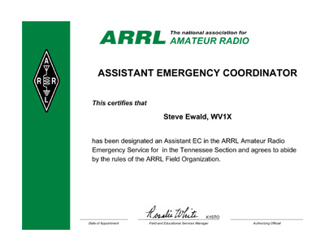The Certificate Maker requires Adobe Acrobat Reader or equivalent to print the forms.
If you or your Section Leadership officials do not have access to the Certificate Maker Web site and the related software and you need assistance in producing AEC
certificates, please contact Leona Adams, at ARRL Headquarters (ladams@arrl.org).

For background on what an Assistant Emergency Coordinator may do and how they may be appointed, refer to Chapter 2.7 and Chapter 3.6 in the ARRL Emergency Coordinator Manual.

